~~ Archbishop Fulton J. Sheen ~~
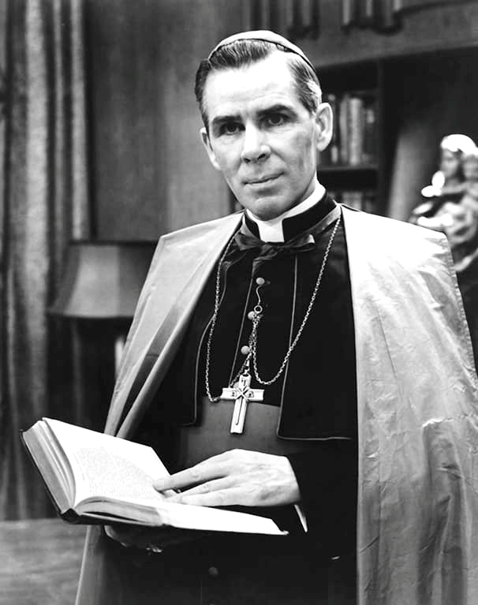
Fulton Sheen was born on May 8, 1895, in El Paso, Illinois, the oldest of four sons of Newton and Delia Sheen. His parents were of Irish descent. He was baptized as
"Peter John". However he came to prefer the name "Fulton", his mother's maiden name.
After the family had moved to nearby Peoria, Illinois, Sheen's first role in the Catholic Church was as an altar boy at Cathedral of Saint Mary of the Immaculate Conception in Peoria.

Sheen graduated in 1913 from high school at Spalding Institute in Peoria with valedictorian honors. He then entered St. Viator College in Bourbonnais, Illinois. Deciding to become a priest, he started his studies at
Saint Paul Seminary in St. Paul, Minnesota.

After Sheen returned to Peoria in 1926, Bishop Dunne assigned him as curate at St. Patrick's, a poor parish in Peoria. At that time, both Columbia University in New York and Oxford University in England wanted Sheen to teach philosophy. However, Sheen took the assignment at St. Patrick's without any complaints and later said that he enjoyed his time there. Nine months later, Dunne summoned Sheen to his office. Dunne told him: I promised you to Catholic University over a year ago. They told me that with all your traipsing around Europe, you'd be so high that you couldn't take orders. But Father Cullen says you've been a good boy at St. Patrick's.
So run along to Washington.

However, instead of Catholic University of America,
Sheen chose to teach theology at
St. Edmund's College in Ware, England.
He also assisted the pastor at St. Patrick's Parish in the Soho section of London. In 1928, Sheen finally
returned to Catholic University of America,
where he would teach philosophy until 1950.

In 1950, Sheen became the national director of the Society for the Propagation of the Faith. During his 16 years as director, Sheen raised millions of dollars for missionary efforts worldwide. He also donated $10 million that he earned from his later television programs.

On May 28, 1951, Pope Pius XII appointed Sheen as an auxiliary bishop for New York. He was consecrated in Rome at the Basilica of Santi Giovanni e Paulo
on June 11, 1951.

On October 6, 1969, Sheen resigned as bishop of Rochester. Pope Paul VI then named him as archbishop of the titular see of Newport, Wales.

Sheen died on December 9, 1979, in his private chapel while praying before the Blessed Sacrament. He was interred in the crypt of St. Patrick's Cathedral near the deceased archbishops of New York. In 2019, after a long legal battle, the archdiocese transferred Sheen's remains to the Diocese of Peoria, which re-interred them in the Cathedral of St. Mary in Peoria.

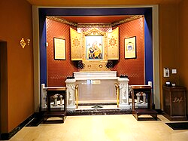
Sheen’s Tomb at St. Mary’s Cathedral in Peoria, Illinois.

Archbishop Fulton J. Sheen is not yet canonized because the Catholic Church’s multi-step sainthood process takes time. He is currently classified as "Venerable," with his official beatification scheduled for September 24, 2026, in St. Louis, Missouri. Fully reaching canonization requires moving through distinct procedural phases and verifying attributed miracles.

The miracle attributed to
Archbishop Fulton J. Sheen involved the apparent resuscitation of James Fulton Engstrom, a newborn boy in Washington, Illinois, who was born stillborn.
In September 2010, Bonnie Engstrom gave birth to her son James, who was completely lifeless, blue, and lacking any signs of respiration or a heartbeat.
Throughout her pregnancy and during the crisis,
the mother had entrusted her baby's health to
Fulton Sheen, continuously repeating his name and asking for his heavenly intercession.
Exactly 61 minutes after birth, just as doctors
were preparing to call the time of death,
the infant's heart suddenly started beating and his
blood pressure normalized.

