~~ Bartholomew the Apostle ~~
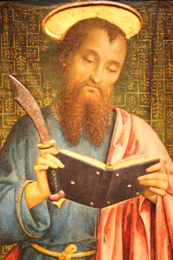
Feast Day ~ August 24th

Bartholomew was one of the twelve apostles of Jesus according to the New Testament. Most scholars today identify Bartholomew as Nathanael, who appears in the Gospel of John.

He was born 23 BC in Cana, Galilee
He died 68 AD in Albanopolis, Kingdome of Armenia.

Eusebius of Caesarea's Ecclesiastical History (5:10) states that after the Ascension, Bartholomew went on a missionary tour to India, where he left behind a copy of the Gospel of Matthew. Tradition narrates that he served as a missionary in Mesopotamia and Parthia, as well as Lycaonia and Ethiopia in other accounts. Popular traditions say that Bartholomew preached the Gospel in India and then went to Greater Armenia.
According to the Visions of the Apostles, Martyrs and Saints recorded by Blessed Anne Catherine Emmerich (1774–1824), Saint Bartholomew first preached the Christian faith in India, where he made numerous converts and left behind several disciples.
Emmerich’s account relates that the apostle journeyed eastward, passing through Japan before returning west by way of Arabia and the Red Sea to Abyssinia (modern-day Ethiopia). There, he is said to have converted King Polymius, raised a man from the dead, and silenced a local idol that had previously spoken to the people. When Bartholomew commanded the demon inhabiting the idol to reveal its deceptions, the spirit confessed that the supposed healings attributed to the idol were illusions meant to maintain idol worship among the populace.
Following this event, the king and his household were baptized, and Bartholomew consecrated the former pagan temple to the worship of the true God. He then healed the sick and became widely loved by the people. However, priests of the old cult later accused him before Astyages, the king’s brother, who ordered his arrest and torture. Emmerich describes Bartholomew’s martyrdom by flaying, during which he continued to preach until his death. His followers are said to have recovered his body and buried it honorably, over which a church was later constructed.
The vision concludes with the conversion of Astyages, while the idol priests are depicted as dying miserably soon afterward. Emmerich also notes that some exegetes have erroneously identified Bartholomew with Nathanael; however, in her visions the two were distinct. Bartholomew (son of Tolmai, of the tribe of Naphtali) preached in India and Armenia, while Nathanael evangelized in Mauretania and Brittany, dying in Tréguier, Brittany.
The 6th-century writer Theodorus Lector asserted that in about 507, the Byzantine emperor Anastasius I Dicorus gave the body of Bartholomew to the city of Daras, in Mesopotamia, which he had recently refounded. The existence of relics at Lipari, a small island off the coast of Sicily, in the part of Italy controlled from Constantinople, was explained by Gregory of Tours by his body having miraculously washed up there. A large piece of his skin and many bones that were kept in the Cathedral of St. Bartholomew in Lipari, were translated to Benevento in 838, where they are still kept in the Basilica San Bartolomeo. A portion of the relics was given in 983 by Otto II, Holy Roman Emperor, to Rome, where it is conserved at San Bartolomeo all'Isola, which was founded on the site of the temple of Asclepius, in pagan times an important Roman medical center. This association with medicine caused Bartholomew's name to become associated in course of time with hospitals.
Saint Bartholomew has been credited with several miracles
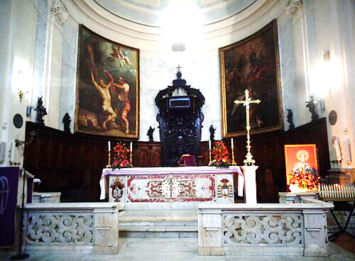
Altar containing the relics of Bartholomew.

