~~ Saint Justin Martyr ~~
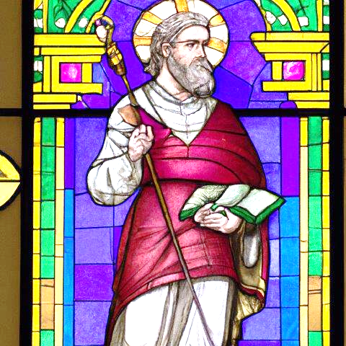
Justin Martyr also known as Justin the Philosopher, was an early Christian apologist and philosopher. The First Apology, his most well-known text, passionately defends the morality of the Christian life and provides various arguments to convince the Roman emperor Antoninus Pius to abandon persecution of the Church. Justin also indicates that historical manifestations of the Logos predated Christ's incarnation, and that many historical philosophers (including Socrates and Plato) were unknowing Christians.

Justin was born c. AD 90–100, into a Greek family, at Flavia Neapolis (today Nablus) near the ancient biblical city of Shechem, in Samaria. He knew little or no Hebrew and Aramaic, and had only a passing acquaintance with Judaism. He defined himself as a Gentile. His grandfather, Bacchius, had a Greek name, while his father, Priscus, bore a Latin name, which has led to speculations that his ancestors may have settled in Neapolis soon after its establishment or that they
were descended from a Roman "diplomatic"
community that had been sent there.

Justin was martyred, along with some of his students, during the reign of Marcus Aurelius around the year 165, and is venerated as a saint by the Catholic Church, the Eastern Orthodox Church, the Oriental Orthodox Churches, Lutheran Churches, and in Anglicanism.

In the opening of the Dialogue, Justin describes his early education, stating that his initial studies left him unsatisfied due to their failure to provide a belief system that would afford theological and metaphysical inspiration to their young pupil. He says he tried first the school of a Stoic philosopher, who was unable to explain God's being to him. He then attended a Peripatetic philosopher but was put off because the philosopher was too eager for his fee. Then he went to hear a Pythagorean philosopher who demanded that he first learn music, astronomy, and geometry, which he did not wish to do. Subsequently, he adopted Platonism after encountering a Platonist thinker who had recently settled in his city.
Sometime afterwards, he chanced upon an old man, possibly a Syrian Christian, in the vicinity of the seashore, who engaged him in a dialogue about God and spoke
of the testimony of the prophets as being more reliable than the reasoning of philosophers.

Moved by the aged man's argument, Justin renounced both his former religious faith and his philosophical background, choosing instead to rededicate his life to the service of the Divine. His newfound convictions were bolstered by the ascetic lives of the early Christians
and the heroic example of the martyrs, whose piety convinced him of the moral and spiritual
superiority of Christian doctrine.

As a result, he thenceforth decided that the only option for him was to travel throughout the land, spreading the knowledge of Christianity as the "true philosophy." His conversion is commonly assumed to have taken place at Ephesus though it may have occurred anywhere on the road from Syria Palestina to Rome.
He then adopted the dress of a philosopher himself and traveled about teaching.

During the reign of Antoninus Pius (138–161), he arrived in Rome and started his own school. Tatian was
one of his pupils. In the reign of
Marcus Aurelius, after disputing with the cynic philosopher Crescens, he was denounced by the latter to the authorities, according to Tatian and Eusebius. Justin was tried, together with six friends (two of them, Euelpistus and Hierax, slaves educated by him), by the urban prefect Junius Rusticus, and was beheaded. Though the precise year of his death is uncertain, it can reasonably be dated by the prefectural term of Rusticus (who governed from 162 to 168). The Christian "Martyrdom of Justin" reports a record of the trial.

The church of St. John the Baptist in Sacrofano, a few miles north of Rome, claims to have his relics.
The Church of the Jesuits in Valletta, Malta, founded by papal decree in 1592, also boasts relics.

Another large reliquary holds a large piece of his bones at a private chapel in Malta that was originally brought from France from a private collection. The reliquary is sealed by a bishop from the 19th century and with saint Justin's bone there are saint Liberata and saint Innocent Martyrs.

A case is also made that the relics of St. Justin are buried in Annapolis, Maryland. During a period of unrest in Italy, a noble family said to be in possession of his remains sent them in 1873 to a priest in Baltimore for safekeeping. They were displayed in St. Mary's Church for a period of time before they were again locked away for safekeeping. The remains were rediscovered and given a proper burial at St. Mary's, with Vatican approval, in 1989.
It is now asserted that the bones were of
St. Justin of the third century who was martyred
during the persecution of Maximus

In 1882, Pope Leo XIII had a Mass and an Office composed for his feast day, which he set at
April 14, one day after the date of his death as indicated in the Martyrology of Florus; but since this date quite often falls within the main Paschal celebrations, the feast was moved in 1968 to June 1st, the date on which he
has been celebrated in the Byzantine Rite
since at least the 9th century.

