~~ Catherine of Siena ~~
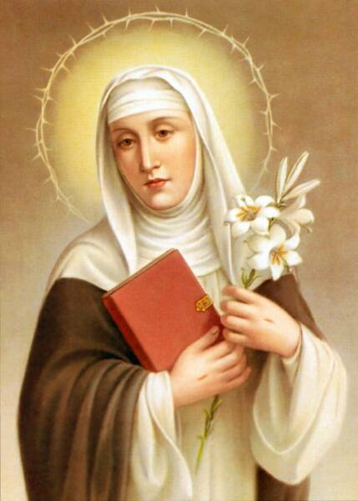
April 29th is the Feast Day of Catherine of Siena

Caterina di Jacopo di Benincasa was born on March 25, 1347 (shortly before the Black Death ravaged Europe) in Siena Italy, to Lapa Piagenti, the daughter of a local poet, and Jacopo di Benincasa, a cloth dyer who ran his
enterprise with the help of his sons.
The house where Catherine grew up still exists.
Lapa was about forty years old when she gave birth prematurely to her 23rd and 24th children, twin daughters, named Catherine and Giovanna. After birth, Giovanna was handed over to a wet nurse and died soon after. Catherine was nursed by her mother and developed into a healthy child. She was two years old when Lapa had her 25th child,
another daughter named Giovanna. As a child,
Catherine was so merry that the family gave her the
pet name of "Euphrosyne", which is Greek for "joy”.

Catherine is said to have had her first vision of Christ when she was five or six years old: she and her brother, Steven, were on their way home from visiting a married sister when she is said to have experienced a vision of Christ seated in glory with the Apostles Peter, Paul, and John. At the age of seven, Catherine vowed to give her whole life to God.

When Catherine was 16, her older sister Bonaventura died in childbirth; already anguished by this, Catherine soon learned that her parents wanted her to marry Bonaventura's widower. She was absolutely opposed and started a strict fast. She had learned this from Bonaventura, whose husband had been far from considerate but had changed his attitude after his wife refused to eat until he showed better manners. Besides fasting, Catherine further disappointed her mother by cutting off
her long hair in protest of being encouraged to improve
her appearance to attract a husband.

As a teenager, when she had times of trouble she would: "Build a cell inside your mind, from which you can never flee." In this inner cell, she made her father into a representation of Christ, her mother into the Blessed Virgin Mary, and her brothers into the Apostles in the New Testament. Serving them humbly became an opportunity for spiritual growth. Catherine resisted the accepted course of marriage and motherhood on the one hand, or a nun's veil on
the other. She chose to live an active and prayerful life outside a convent's walls, following the model of the Dominicans. Eventually, her parents gave up and permitted her to live as she pleased and stay unmarried.

A vision of St. Dominic Guzmán gave strength to Catherine, but her wish to join his order was no comfort to Lapa, who took her daughter with her to the baths in Bagno Vignoni
to improve her health. Catherine fell seriously ill with a violent rash, fever and pain, which conveniently made her Mother accept her wish to join the "Mantellate",
the local association of devout women.
The Mantellate taught Catherine how to read, and she lived in almost total silence and solitude in the family home.

It was customary for Catherine to give away clothing and food without asking anyone's permission, which cost her family significantly. However, she requested nothing for herself and by staying in their midst, she could live out her rejection of them more strongly. She did not want their food, referring to the table laid for her in Heaven with her real family.

Shortly after joining the Mantellate, Catherine started to fast for longer but found it challenging. While tending to a woman with cancerous breast sores, she was disgusted. Intending to overcome that disgust, she gathered the sore pus into a ladle and drank it all. That night, she was visited by Jesus who invited her to drink the blood gushing out of his pierced side. It was with this visitation that her stomach "no longer had need of food and no longer could digest”.

In late November 1378, with the outbreak of the Western Schism, the new Pope, Urban VI, summoned her to Rome. She stayed at Pope Urban VI's court and tried to convince nobles and cardinals of his legitimacy, both meeting with individuals at court and writing letters to persuade others.
For many years she had accustomed herself to a rigorous abstinence. She received the Holy Eucharist almost daily.
This extreme fasting appeared unhealthy in the eyes of the clergy and her own sisterhood. Her confessor, Raymond, ordered her to eat properly. However, Catherine replied that she was unable to, describing her inability to eat as an illness. From the beginning of 1380, Catherine could neither eat nor swallow water. On February 26, she lost the use of her legs.
Catherine died in Rome on April 29,1380, at the age of thirty-three, having suffered a massive stroke eight days earlier, which paralyzed her from the waist down.
Her last words were,
"Father, into Your Hands I commend my soul and my spirit."

Devotion around Catherine of Siena developed rapidly after her death. Pope Pius II canonized her on June 29, 1461; she was declared a [patron saint] of Rome in 1866 by Pope Pius IX, and of Italy (together with Francis of Assisi) in 1939 by Pope Pius XII. She was the second woman to be declared a Doctor of the Church, on October 4, 1970 by Pope Paul VI – only days after Teresa of Ávila.
In 1999 Pope John Paul II proclaimed her a Patron Saint of Europe.
Catherine of Siena is one of the outstanding figures of medieval Catholicism due to the strong influence she had in the history of the papacy and her extensive authorship. She was behind the return of the Pope from Avignon to Rome, and then carried out many missions entrusted to her by the pope, something quite rare for a woman in the Middle Ages. Her Dialogue, hundreds of letters, and dozens of prayers also give her a prominent place in the history of Italian literature.

