~~ Saint Thomas Aquinas ~~
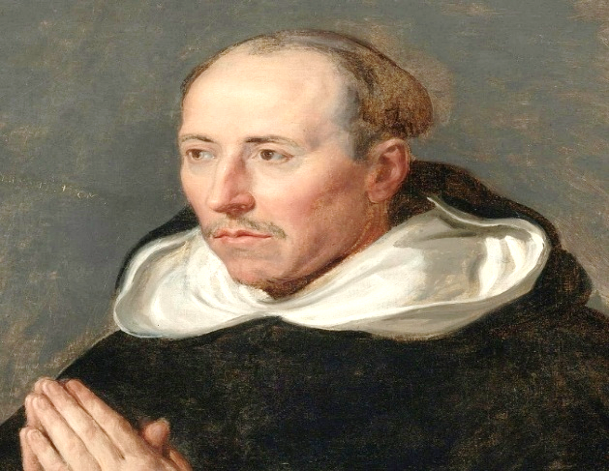
Thomas Aquinas was most likely born in the family castle near Aquino, controlled at that time by the Kingdom of Sicily in 1225. He was born to the most powerful branch of the family, and his father, Landulf VI of Aquino, Lord of Roccasecca, was a man of means and was a knight in the service of Frederick II the Holy Roman Emperor. Thomas's mother, Theodora Galluccio, Countess of Teano, belonged to the Rossi branch of the Neapolitan Caracciolo family. Thomas’ uncle, Sinibald, was abbot of Monte Cassino, the oldest Benedictine monastery. Thomas was the youngest of four sons and had two sisters. While the rest of the family's sons pursued military careers, the family intended for Thomas to follow his uncle into the abbacy; this would have been a normal career path for a younger son of Southern Italian nobility.

At the age of five, Thomas began his early education at Monte Cassino. After the military conflict between Frederick II and Pope Gregory IX spilt the abbey
in early 1239, Landulf and Theodora had Thomas enrolled at the university established by Frederick in Naples.
It was at this university that Thomas was presumably introduced to Aristotle, Averroes and Maimonides, all of whom would influence his theological philosophy.
During his study at Naples, Thomas also came under the influence of John of St. Julian, a Dominican preacher in Naples, who was part of the active effort by the
Dominican Order to recruit devout followers.

At the age of nineteen, Thomas resolved to join the Dominican Order. His change of heart, however, did not please his family. In an attempt to prevent Theodora's interference in Thomas's choice, the Dominicans arranged to move Thomas to Rome, and from Rome, to Paris. However, while on his journey to Rome, per Theodora's instructions, his brothers seized him as he was drinking from a spring and took him back to his parents.
Thomas was held prisoner for almost one year in the family castles at Monte San Giovanni and Roccasecca in an attempt to prevent him from assuming the Dominican habit and to push him into renouncing his new aspiration. Political concerns prevented the Pope from ordering Thomas's release, which had the effect of extending Thomas's detention. Thomas passed this time
of trial tutoring his sisters and communicating
with members of the Dominican Order.

Timeline from 1244 until his death in 1274

1244 - Theodora arranged for his escape at night. In her mind a secret escape from detention was less damaging than an open surrender to the Dominicans.
1245 - Sent to study at the Faculty of the Arts at the University of Paris.
1252 - Returned to Paris to study for a master's degree in theology.
1252 to 1257 - Lived and worked with Saint Bonaventure, he was also personal advisor to Saint Louis IX of France.
1256 - Appointed regent master in theology at Paris.
1259 - Completed his first regency at the studium generale and left Paris.
1260 - Appointed as general preacher by the provincial chapter.
1265 - Pope Clement IV summoned Thomas to Rome to serve as papal theologian.
1268 - Returned to Paris for a second teaching regency.
1268 - The Dominican Order assigned Thomas to be regent master at the University of Paris for a second time, a position he held until early 1272.
1272 – He took leave from the University of Paris when the Dominicans from his home province called upon him to establish a studium generale wherever he liked and staff it as he pleased.
1273 - At the Dominican convent of Naples in the chapel of Saint Nicholas, after matins, Thomas lingered and was seen by the sacristan Domenic of Caserta to be levitating in prayer with tears before an icon of the crucified Christ.
1273 - December 6 - another mystical experience took place. While Thomas was celebrating mass, he experienced an unusually long ecstasy.
1274 - Pope Gregory X summoned Thomas to attend the Second Council of Lyon.

The council was to open May 1, 1274, and it was Gregory's attempt to try to heal the Great Schism of 1054, which had divided the Catholic Church in the West from the Eastern Orthodox Church. At the meeting, Thomas's work for Pope Urban IV concerning the Greeks, was to be presented. However, on his way to the council, riding on a donkey along the Appian Way, he struck his head on the branch of a fallen tree and became seriously ill.

He was then quickly escorted to Monte Cassino to convalesce. After resting for a while, he set out again but stopped at the Cistercian Fossanova Abbey after again falling ill. The monks nursed him for several days, and as he received his last rites he prayed:
"I have written and taught much about this very
holy Body, and about the other sacraments in the
faith of Christ, and about the Holy Roman Church,
to whose correction I expose and submit
everything I have written."

He died on March 7, 1274
while giving commentary on the Song of Songs.

Fifty years after Thomas's death, on July 18, 1323,
Pope John XXII, seated in Avignon,
pronounced Thomas a saint.

