Sunday, December 3, 8:00 a.m., 1st Sunday of Advent
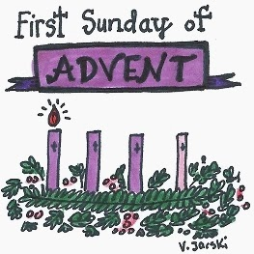

MINISTERS: Jeri Erickson & Ginny Heintzelman
LECTOR: Vivian Heltemes
USHERS: Jeramee VanEps & Ron Draper
SERVERS: Otto Kleindl & Xavier Kleindl
SACRISTANS: Larry & Ginny Heintzelman

Thursday, December 7, Immaculate Conception, 5:00 p.m.

MINISTERS: John Berlinger & David Asfeld
LECTOR: Paula Baxter
USHERS: Mark Lampert & Jim Stock
SERVERS: Katlin Gibson & Sydney Gibson
SACRISTAN: John & Mary Lou Berlinger

Sunday, December 10 – 8:00 a.m., 2nd Sunday of Advent
MINISTERS: Jerry Heltemes & Scott Gonnerman
LECTORS: Faith Formation Students/Rachel Schott
USHERS: Mark Gibson & Brian Marty
SERVERS: Andrew Marty & Hannah Marty
SACRISTAN: Keith & Maria Marty

Sunday, December 17 – 8:00 a.m., 3rd Sunday of Advent
MINISTERS: Anita Marty, Jamie VanEps, Jeri Erickson, Bruce Berlinger
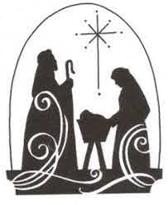
LECTOR: Nancy Leuthard
USHERS: Brock Marty & John Kleindl
SERVERS: Landen Gibson & Zachary Kleindl
SACRISTANS: David Asfeld

Sunday, December 24—8:00 a.m., 4th Sunday of Advent
MINISTERS: David Asfeld & John Berlinger
LECTOR: Sandi Marlow-Weber
USHERS: Keith & Maria Marty
SERVERS: Lincoln Schneider & Berdine Kleindl
SACRISTAN: Rachel Schott

Sunday, December 24 – 4:00 p.m., Christmas Eve
MINISTERS: Anita Marty, Jamie VanEps, Bruce Berlinger, Jerry Heltemes
LECTOR: Paul Daly
USHERS: Jacob Marty & Ron Draper
SERVERS: Jace & Josie Kleindl
SACRISTAN: John & Mary Lou Berlinger

Sunday, December 31 – 8:00 a.m., The Holy Family of Jesus, Mary & Joseph
MINISTERS: Ginny Heintzelman & Scott Gonnerman

LECTOR: David Asfeld
USHERS: Jerry Heltemes & Larry Heintzelman
SERVERS: Jade Marty & Jameson VanEps
SACRISTANS: Larry & Ginny Heintzelman

Note: January 1st, Solemnity of Mary, is nonobligatory this year. The only New Years Day Mass is in Browns Valley, 8:30 am.

