Sunday, January 6 – 8:30 a.m.
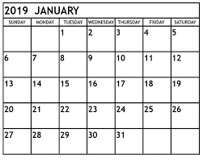

MINISTERS: Tony Ritter & Jamie Van Eps
LECTOR: Robyn Lampert
USHERS: Keith & Maria Marty
SERVERS: Reilly, Landen, & Katlin Gibson
SACRISTANS: Keith & Maria Marty

Sunday, January 13 – 8:30 a.m.

MINISTERS: Jeri Erickson, Eileen Marquardt, & John Berlinger
LECTORS: Caryn Marty & Abby Warnock
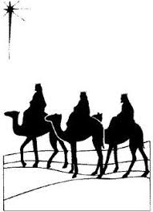
USHERS: Caryn Marty & Abby Warnock
SERVERS: Andrew & Brock Marty
SACRISTANS: John & Mary Lou Berlinger

Sunday, January 20 – 8:30 a.m.
MINISTERS: Rich Weber & Dean Quackenbush
LECTOR: Sandi Marlow-Weber
USHERS: Brian Marty & Mark Lampert
SERVERS: John & Jace Kleindl
SACRISTAN: Jodi DeCamp

Sunday, January 27 – 8:30 a.m.
MINISTERS: Anita Marty & Ginny Heintzelman LECTOR: Vivian Heltemes
USHERS: Larry Heintzelman & Jim Stock
SERVERS: Berdine & Xavier Kleindl
SACRISTANS: Larry & Ginny Heintzelman
